**Unit: Manual Motor Controls Test: Midterm**

**Midterm CLO#: 1**

Name ______________________________ Date ______________

**Instructions**

Fill in the description and I/O columns for each NEMA schematic symbol below.

|  | Symbol | Description | I/O |
| --- | --- | --- | --- |
| 1 |  |  |  |
| 2 |  |  |  |
| 3 |  |  |  |
| 4 |  |  |  |

|  | Symbol | Description | I/O |
| --- | --- | --- | --- |
| 5 |  |  |  |
| 6 |  |  |  |
| 7 |  |  |  |
| 8 |  |  |  |
| 9 |  |  |  |
| 10 |  |  |  |
| 11 |  |  |  |
| 12 |  |  |  |
| 13 |  |  |  |
| 14 |  |  |  |
| 15 |  |  |  |
| 16 |  |  |  |
| 17 |  |  |  |
| 18 |  |  |  |
| 19 |  |  |  |
| 20 |  |  |  |
| 21 |  |  |  |
| 22 |  |  |  |
| 23 |  |  |  |
| 24 |  |  |  |
| 25 |  |  |  |

Identify each component of the AC single-phase motor.

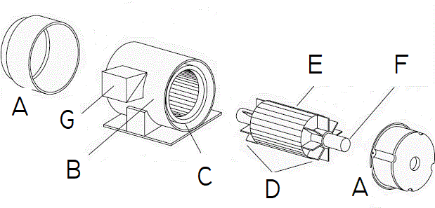

|  |  |  |  |
| --- | --- | --- | --- |
| 1. Fans |  | 1. Stator |  |
| 1. Terminal Box |  | 1. Shaft |  |
| 1. Windings |  | 1. End Bells |  |
| 1. Rotor |  |  |  |

1. What is the term used in the field for the Single-Phase AC induction motor that we are using in class?
   1. Rat cage
   2. Hamster wheel
   3. Squirrel cage
   4. Mouse trap
2. What is the field term for the terminal box on the side of a motor?
3. Dim-head
4. Pecker-head
5. Knock box
6. Hot box

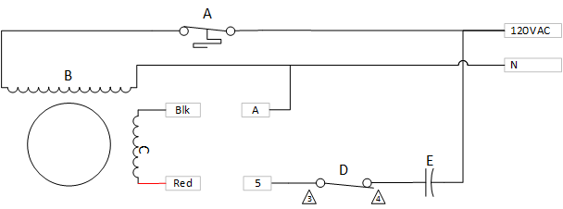

1. Match the components in the above single-phase motor schematic to their components.
   1. ______________ Start Switch
   2. ______________ Capacitor
   3. ______________ Thermal Switch
   4. ______________ Run Windings
   5. ______________ Start Windings
2. If the motor is running CW with Blk wired to 5 and Red wired to A, how should the motor be re-wired to obtain a CCW rotation?
3. Explain why re-wiring this winding causes the motor to rotate in the opposite direction?
4. AC is flowing in the other direction
5. The poles of the start windings are reversed
6. A switch inside the motor is changed
7. The capacitor is reversed in the circuit
8. This motor can change its rotation while running.
   1. True
   2. False
9. How does having a capacitor in the circuit cause the motor to rotate in one direction or the other?
   1. There is a phase shift where voltage leads the current
   2. The capacitor changes the direction of current
   3. These is a phase shift where current leads the voltage
   4. The capacitor does not help change direction
10. An AC induction motor has a permanent magnet that creates the magnetic field.
    1. True
    2. False
11. Reducing the voltage of an AC induction motor will reduce the speed of the motor.
    1. True
    2. False
12. A motor’s RPM rating is determined when
    1. Maximum Applied Voltage
    2. When the motor is under full load
    3. Sea Level
    4. When the motor is below FLA
13. Most industrial motors are of what type?
    1. Single-phase squirrel cage
    2. Three-phase induction
    3. Split-phase wire-wound
    4. Single-phase shunt-wound
14. What is motor slip?
    1. The difference between the power input to a motor and the actual shaft RPM
    2. The difference between a motors synchronous speed and actual shaft RPM
    3. The difference between the voltage input to a motor and the actual shaft RPM
    4. The difference between the current input to a motor and the actual shaft RPM
15. What article of the NEC covers motor information?
    1. 315.16
    2. 334
    3. 400
    4. 430
16. Motors in the US are rated by
    1. NEMA
    2. IEC
    3. NEC
    4. EPA
17. In a single-phase system, how many degrees are there between each sine wave?
    1. 90
    2. 120
    3. 180
    4. 360
18. In a split-phase system, how many degrees are there between each sine wave?
    1. 90
    2. 120
    3. 180
    4. 360
19. In a three-phase system, how many degrees are there between each sine wave?
    1. 90
    2. 120
    3. 180
    4. 360
20. List three general types of three-phase motors.
    1. Squirrel cage, shunt-wound, asynchronous motors
    2. Induction, wound rotor and synchronous motors
    3. Dual-voltage, wound rotor and shunt-wound
    4. None of the above
21. The speed of a squirrel cage induction motor depends on
    1. Applied Voltage
    2. The frequency and the number of poles
    3. Magnetic field strength
    4. Current magnitude
22. What is the purpose of the laminated iron plates within the rotor?
    1. Aid in electromagnetic induction
    2. Reduce Eddy-currents
    3. Reduce hysteresis
    4. B and C
    5. All the above
23. If a motor has an enclosure type of ODP, what does that indicate?
    1. Outdoor Protected
    2. Open Drip-proof
    3. Oxidized Dielectric Protected
    4. Open Door Plenum
24. When a motor has an enclosure type of TEFC, that indicates that it is;
    1. Totally Enclosed Fan Cooled
    2. Total Environment Face Cowling
    3. Thin Electric Face Cooled
    4. Totally Electric Fan Cooled
25. A motor has an enclosure type of TENV, what type of environment would it be used?
    1. A clean-room
    2. Submerged in a settling pond
    3. A Chemical plant with a harsh environment
    4. None of the above
26. What type of motor would you use at Laclede gas to pump natural gas?
    1. ODP
    2. EXP
    3. TEFC
    4. TENV
27. A continuous duty cycle motor can operate at its rated HP for at least;
    1. 20 minutes
    2. 3 hours
    3. 12 hours
    4. 24/7/365
28. The locked rotor code letter and the NEMA design code letter indicate the same characteristic about a motor?
    1. True
    2. False
29. Motors in Europe are rated by
    1. NEMA
    2. IEC
    3. NEC
    4. EPA
30. Why would it be good the select a motor that has a SF > 1?
    1. Allows winding temperatures to be cooler.
    2. Protects against heat spikes
    3. Bearings will last longer
    4. A and B
    5. All the above
31. What does FLA indicate?
    1. Flange size
    2. Max Running Current
    3. Fuse Protection
    4. Face mounted
32. What is the effect of operating a motor above its HP but within its SF?
    1. Causes a reduction in motor RPM
    2. Will reduce Life Span
    3. Causes the motor’s efficiency to decrease
    4. A and C
    5. All the above
33. If a 5HP motor has a service factor of 1.5, what HP can the motor be loaded to?
    1. 5HP
    2. 5.25HP
    3. 7.5HP
    4. Service factor has nothing to do with horsepower.
34. A motor is rated at 208V @ 50 Hz. If this motor is installed in the US, the motor will;
    1. Run slower
    2. Run faster
    3. Overhead
    4. Not work

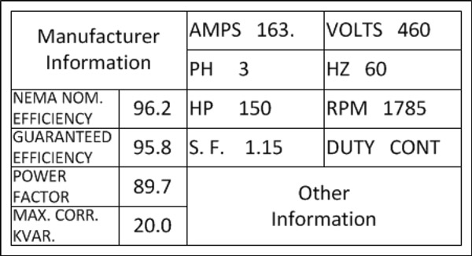

1. How many watts should this motor dissipate? ______________
2. What nominal voltage level would you use to connect to this motor? ____
3. What is the acceptable range of voltage input to this motor connected to that voltage range? _______ to _______
4. Based on the RPM of this motor, how many poles would it have? _______
5. What is its percentage slip? __________
6. What is motor Efficiency?
   1. How fast the shaft turns verses the motors rated RPM
   2. How well the motor translates electrical power into rotational power
   3. How quickly the motor gets to full speed on startup
   4. How often the motor needs to rest
7. If a motor is not continuous duty, it is designated as?
   1. Partial duty
   2. Service duty
   3. Intermittent duty
   4. B and C
   5. All the above
8. When a motor is rated for inverter duty, what does that indicate?
   1. It can be used on a solar system
   2. It can be used with a variable frequency drive.
   3. It is a DC motor that will accept an AC input source
   4. It is reversible
9. A motors *Power Factor (PF)* is useful to determine
   1. The motors efficiency
   2. The motors power requirements
   3. The overall quality of the motor
   4. All of the above
10. In the diagram below show how you would connect the motor to its lower voltage. Show jumper connections and L1, L2, L3 input lines.



Match the motor characteristics with the nameplate below.

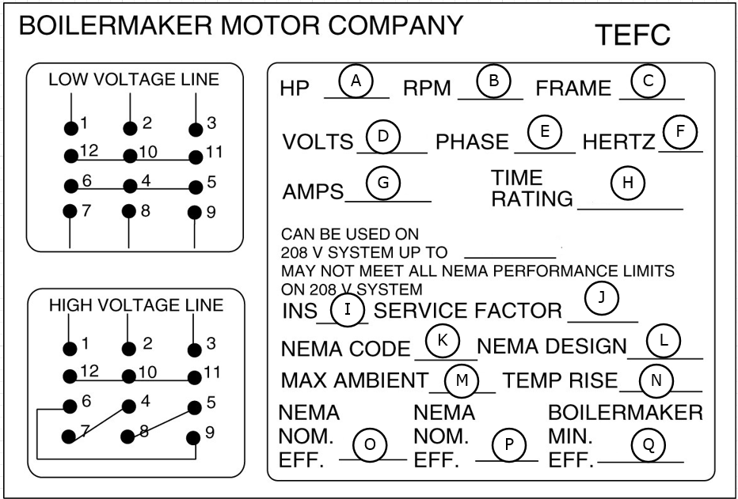

1. Insulation Type _______
2. How long the motor can run _______
3. Three-Phase Motor _______
4. Shaft Speed _______
5. Applied Power _______
6. Locked Rotor Current _______
7. Service Frequency _______
8. Motor Physical Dimensions _______
9. Output Power _______
10. Draw a schematic for a 208V three-phase motor that is controlled by a motor starter. (three-phase portion only)
11. Construct the formula for the motor control schematic below.

